**Software Engineering And Information Design Sessional**

**Project Name:Osmany Hall Messing System**

**Group No:06**

**Group member’s Name**

**Anusha Kabir(201414081)**

**Naznin Sultana Refath(201414094)**

**Mehreen Hoque(201414098)**

**Nabila Shahnaz Khan(201414105)**

**Anika Ibnat(201414109)**

**Adnan Sharif(201414114)**

**Umme Hany(201214018)**

**Index**

Software scopes and features……………………………………………………………..03

Hardware requirements……..……………………………………………………………….03

Software requirements……………………………………………………………………….05

System requirements………………………………………………………………………….05

# Overall System Architecture…………………………………………………………….. 06

Module solution architecture……………………………………………………………

Data flow diagram (dfd)…………………………………………………………………….

Class diagram…………………………………………………………………………………….

Use case diagram………………………………………………………………………………

Use case scenario……………………………………………………………………………..

Sequence diagram…………………………………………………………………………….

# 

# Software Scopes and Features

The aim of this software is to make the billing system and meal signing system of Osmany Hall easier, keep the students up-to-date about their bill payment status, let them check their dues and monthly food bill in details, prevent from someone else signing their meal and prevent wastage of food in the hall.

The software has following modules:

* + Open account
  + Log in
  + Sign meal
  + View meal
  + View hall bill
  + view mess bill
  + input daily consumption
  + edit student information

# Hardware Requirements

**Minimum Requirements for Server:**

* PROCESSOR: Intel Pentium
* RAM: 1 GB
* HARD DISK: 80 GB (5400 rpm)
* MONITOR: Color monitor with 1024x768 resolutions UPS (for uninterrupted power

supply)

* Other equipments are needed to be suitable as per upper mentioned tools.

**Recommended Requirements for Server:**

* PROCESSOR: core i3
* RAM: 4 GB (or more) RAM for both database server & application server
* HARD DISK: 200 GB ((7200 rpm)) hard disk for application server (It will be best to keep more space for application server hard disk).
* MONITOR: Color monitor with 1280x1024 resolutions
* UPS (for uninterrupted power supply)
* Other equipments are needed to be suitable as per upper mentioned tools.

**Minimum Requirements for Workstation:**

* PROCESSOR: Intel /AMD 1.0GHZ
* RAM: 256 MB
* HARD DISK: 20 GB (5400 rpm)
* MONITOR: Color monitor with 1024x768 resolutions
* UPS (for uninterrupted power supply)
* Other equipments are needed to be suitable as per upper mentioned tools.

**Recommended Requirements for Workstation:**

* PROCESSOR: Intel /AMD 1.6 GHZ (or more)
* RAM: 512 MB (or more)
* HARD DISK: 20 GB (7200 rpm)
* MONITOR: Color monitor with 1024x768 resolutions
* UPS (for uninterrupted power supply)
* Other equipments are needed to be suitable as per upper mentioned tools.

# Software Requirements

**Application Server Requirement**

* **Operating System**: Windows xp
* **Web Server**: chrome or mozilla
* **IIS** : 6.0
* **Tomcat** : 5.0
* **Dot Net Framework** : 2.0
* **Fingerprint** : Webkey Service and Utility 3.01.287 (for Server)
* **Database** : Oracle 10g Client

**Database Server Requirement**

* **Operating System**: Windows xp
* **Database** : MySQL

**Client Side Requirement**

* **Operating System:** Windows/Linux/MAC OS.
* **Browser** : Mozilla Firefox 3.5 or Later
* **Flash player** : 10.0 Plug-in
* **Webcam** : Logitech Quickcam 10.0
* **Fingerprint** : Webkey Service and Utility 3.01.287 (for Client)
* **User & System Requirements:**

User requirements talk about the problem domain, the world of the user and they depends upon how user can use the software. It is a list of features an application must/should have. For our hall messing system, the possible users are the students, hall staffs, hall manager and hall authority (provost, assistant provost).

On the other hand, System requirements talk about the solution domain, the world of the software logic. They represent all of the requirements at the *system level* that describe the functions which the system as a whole should fulfill to satisfy the stakeholder needs and requirements and is expressed in an appropriate combination of textual statements, views, and non-functional requirements. Our user and system requirements are given below:

**Students:**

**For User:**

1. Students should be able to sign on/off meal anywhere anytime.

**For System:**

1.1 Student can sign on/off their meal for the next day.

1.2 They have to sign it before 2230 hours because after that time the hall staffs has to order meal.

1.3 Students can sign it from anywhere through website but he needs to log in to his account using his hall id and password.

**For User:**

2. Students should be able to view the mess bill and hall bill.

**For System:**

2.1 Students can view their mess/hall bill of previous months.

2.2 Students can also see if the bill is paid or not.

2.3 Students can see the amounts they have paid till last month from the beginning and see if they have paid less or more than the required bill and if he has paid more, how much extra money is left to his account.

2.4 To view this they also need to log in to the system using their hall id and password.

**For User:**

3. Students should be able to read notice.

**For System:**

3.1 Students can read the notice through website.

3.2 There will be a notice section in website where all the notices will be published with their publishing dates.

3.2 This feature also requires valid log in.

**For User:**

4. Student should be able to update their personal information

**For System:**

4.1 Student shall be able to update some of their information that changes frequently i.e. contact information, present address, Local Guardian etc.

4.2 To do this, student needs to log in to their account.

**Hall staffs:**

**For User:**

5. Hall staffs should be able to insert the list of purchased groceries and the expense.

**For System:**

5.1 Hall staffs should be able to input purchased groceries and amount for the previous days up to today by signing into the page assigned to him.

5.2 There will be four columns item name, price per unit, total unit and price.

5.3 There will be two option.

**⇒**Store in: In this system he will be able to input the information of buying the groceries.

**⇒**Day basis expense: He can store all the items along with their expense on daily basis.

**For User:**

6. Hall staffs should be able to activate or deactivate meal status of students.

**For System:**

6.1 In case a student haven’t paid his dues, it is allowed to the hall staffs to sign on/off meal for the students. He will be able to activate or deactivate account for each student account. If he deactivates a student’s account with one of the specific reasons given below, the student will be able to view all his bills but won’t be able to on his meal.

6.2 For hall staffs, it is allowed to turn on/off today’s and tomorrow’s meal.

**For User:**

7. Hall staffs should be able to edit meal chart.

**For System:**

7.1 Every month, the meal chart is changed in the hall according to student’s choice. The hall staff will be able to update these changes through his page after logging in.

**Hall manager/ authority:**

**For User:**

8. He should be able to admit new students to hall and can also deactivate accounts of students.

**For System:**

8.1 When a new students admit into hall. The hall manager will insert the students necessary information (i.e. students name, department, student id, session, present address, permanent address, contact no, guardian’s information etc.).

8.2 When a student cancel his/her admission to hall, the hall manager can deactivate his/her account so that no further mess bill or hall bill should not be added his/her account.

8.3 If that student again re-admitted into hall, the hall manager can activate that students account again.

**For User:**

9. He should be able to enlist all the students who have paid bill timely and who haven’t.

**For System:**

9.1 The hall manager can generate list of student who paid the bill and who haven’t of a particular month.

9.2 He can also generate the report of students who have overdue. (Total due money greater than a specific amount)

**For User:**

10. He should be able to keep track of all the hall expenses and accounts.

**For System:**

10.1 The hall accounting information (viewing and editing) will be accessible from the hall manager and hall authority’s account.

**For User:**

11.   Hall Manager should be able to enter the notice.

**For System:**

11.1 Hall manager will have his own account, by logging into the account he can post notices in the notice section.

11.2 He can edit notice before publish it.

11.3 He can view preview of the notice.

11.4 Total 10 notice can be stored into the notice section. To publish new notice, the hall manager needs to remove one of the previous notice.

11.5 Hall manager can show/hide notices.

**For user:**

12. Hall manager should be able to edit the information.

**For System:**

12.1 Hall manager shall be able to able to edit information of student.

12.2 In case of any mistakes occur by the hall staff, The Hall manager shall be able to change that.

**For user:**

13. If a student forget their password, hall manager can change it.

**For System:**

13.1 If a student forget their password, they need to submit an application to hall manager.

13.2 Hall manager then change the password.

13.3 The soft copy of the application is required while changing the password.

* **Functional Requirements:**

In Software engineering and systems engineering, a functional requirement defines a function of a system or its component means functional requirements describe what the system should do. In our hall messing system, the prime functional requirements are:

1. Every student shall be uniquely identified by their student id and hall stuff, manager, authority shall be uniquely identified by their employee id which they will use as their username to sign in to their accounts.
2. The students shall be able to see the notices in the home page.
3. There shall be individual accounts for each students, hall manager, hall staff and the administrator. They shall be able to log in to their account by selecting their role (i.e. student, hall-staff, hall-manager, admin) and entering their username and password.
4. Students shall be able to view the contact information of hall staffs and authority along with the dos and don’ts applicable for students residing at hall.
5. On signing in to the individual account a student shall be allowed to alter certain permitted information like address, phone, email etc. and as such hall authority will remain updated about each student.
6. Signing in to the account shall enable a student to view to options  
     
    **⇒**Hall bill  
    **⇒**Mess bill  
     
   On clicking the hall bill option student can view monthly bill, amount deposited, shortage or remaining amount in the account and also the fines they have been charged due to late deposition.  
     
   On clicking the mess bill option students will be able to view the monthly mess bill, the amount short or the amount still remaining in the account.
7. Individual student account shall let the student sign his meal. Students are allowed to sign the meal for the next day just the day before.
8. Hall staffs shall be able to view list of students who signed their meal. He can search students by their ID, hall ID to sign that particular student’s meal. He has the authority to deactivate meal signing option of a student if he hasn’t cleared his dues.
9. Hall staffs shall insert the list of groceries bought including their price, amount, price per unit to keep track of the hall expenses and also the amount deposited by the students every month.
10. The hall manager and the hall authority shall have the authority to see the amount of bills paid by all the students till now and also the monthly amount of expenses of the hall in detail. Thus they can control the overall accounting system of the hall.
11. The hall manager can post urgent notices in the notice section and he can allocate or cancel hall seats.

* **Non Functional Requirements:**

In systems engineering and requirements engineering, a non-functional requirement is a requirement that specifies criteria that can be used to judge the operation of a system, rather than specific behaviors. [7] In short, non-functional requirements describe how the system works.

Some non-functional requirements of our system is given below:

* **Performance Requirement**: Every function provided by the system should be robust without slowing down the system or annoying the users. According to our statement, if a student do not signed his/her meal manually, he/she has to sign it online. So there will be a lot of query online at the same time. So the system should not slow down due to the number of queries at a time.
* **Space Requirement:** The database shall contain all the information till it has been created. So, the database needs to be as efficient as possible to maintain disk space. As the system is web-base, the web-page should be efficient also so that the user needs less data-usage to load the web-page.
* **Usability Requirement:** The Hall Messing System should be available for 24 hours to all students and hall employees.  If the system goes down ever, it shouldn’t be down for more than 15 minutes.
* **Dependability Requirement:** Though we are trying to make whole process online so that anyone can get service from anywhere, we are considering not to be fully dependent on the online system. So, students can sign their meal manually at the hall office. Later the hall staff will update the information as per his comfortable time. So, in case of any internet failure, the process won’t get disturbed.
* **Security Requirement:** To ensure the security each students shall have separate accounts along with username and password. Whenever someone logs into his account, an immediate mail shall be sent to him to make sure that no else had logged into his account. So no student can access another student’s account without their help.
* **Operational Requirement:**  All the information provided by the system should be up-to-date and correct. The staff can only insert amount paid and meal expenses of the present time, but only the hall manager and hall authority shall have access to the complete information of student bill, amount of groceries used and hall expenses till date for security purpose.
* **Environment Requirement:** The system can be operated at any environment. We set our platform to be web-based so that it can be accessible from any devices/environment. No matter the user uses Windows, Linux, Mac or Android environment, our system can be accessible.
* **Development Requirement:** User interface of the system shall be easy to understand for the user. The user shall not need any previous experience to use the system properly.
* **Regulatory Requirement:** The system should be tested every 3 years. In case of any major change in hall messing system, the system should be updated**.**
* **Ethical Requirement:** Every individual account should be accessed by only the legal account owner.
* **Accounting Requirement:** The system will do necessary accounting by itself. No manual accounting is needed. The system requires necessary data to perform accounting.

# Overall System Architecture:

Overall system will inter communicate through the client’s intranet. A sample structure for the system is defined below.

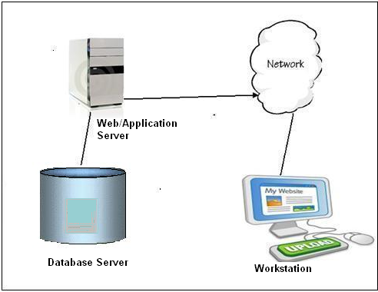

# Module Solution Architecture:



* **Context diagram:**

A system context diagram (SCD) in [software engineering](https://en.wikipedia.org/wiki/Software_engineering) and [systems engineering](https://en.wikipedia.org/wiki/Systems_engineering) is a [diagram](https://en.wikipedia.org/wiki/Diagram) that defines the boundary between the [system](https://en.wikipedia.org/wiki/System), or part of a system, and its environment, showing the entities that interact with it. This diagram is a high level view of a [system](https://en.wikipedia.org/wiki/System). It is similar to a [block diagram](https://en.wikipedia.org/wiki/Block_diagram).

In our project, the account is basically the center of the context diagram is account which represents the system. The entities surrounding it has link to the center. Labelled lines between the entities and the system shows relationship between them.

A Context Diagram (and a DFD for that matter) provides no information about the timing, sequencing, or synchronization of processes such as which processes occur in sequence or inparallel.  Therefore it should not be confused with a flowchart or process flow which can show these things.

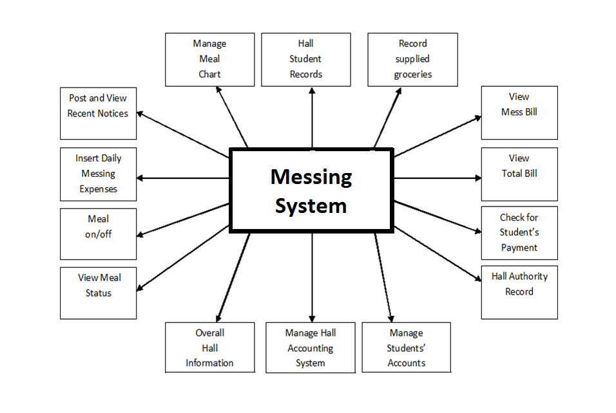

* **Osmani hall messing system data flow diagrams**

The data flow diagram of our project was designed according to our projects features. The main 4 features were used as criteria to create four different data flow diagrams. Those are given below:

1. **Check bill for students:**

Student can check their bill through our website. The main entity of this dfd is student. At first he collects info for logging in which is his username and password. Then the validity of the collected data is checked. Collect data and validity check are processes here. If the information is valid and student requests for bill, both the mess bill and hall bill can be viewed of anytime through view bill process.

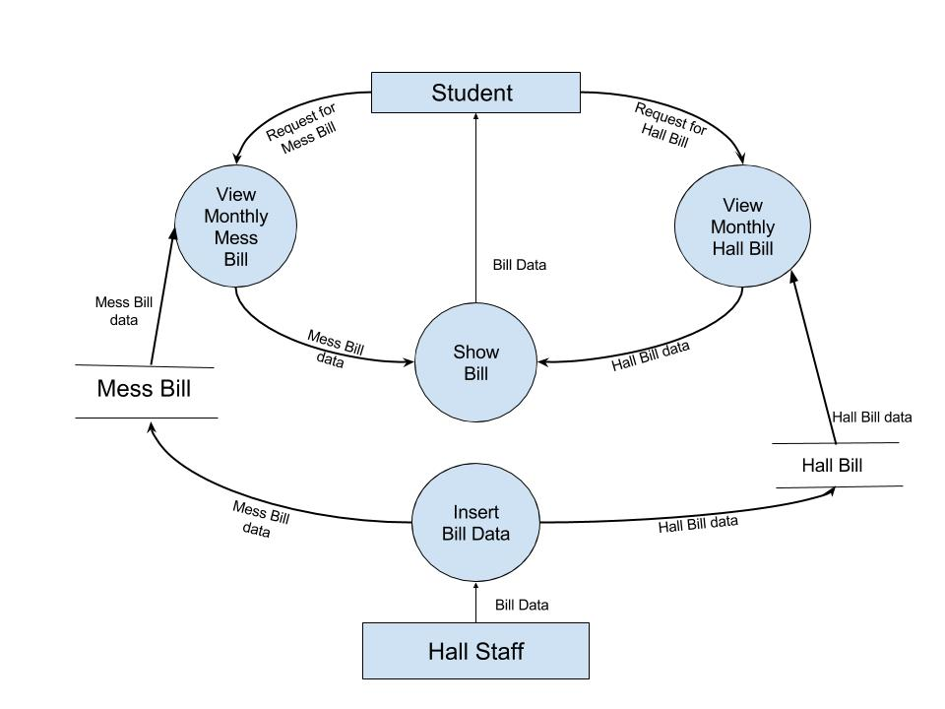

**Fig:** DFD For Checking Bill

Hall staff can insert bill data of the student mess bill and hall bill through the data store mess bill where all the information of mess bill of student and hall bill where all the information about hall bill of a student.

1. **Meal sign for students:**

At first the collect info check validity info works as same as bill sign. View meal status let students to view their meal status. If they are eligible to sign meal, the next process helps them sign meal and entry info into the database. If the account is not eligible the reject message send to the student.When a student sign the meal the information add to meal database.Data about the monthly mess bill payment can also be checked through monthly mess bill.The modify info process modifies student information regarding meal.

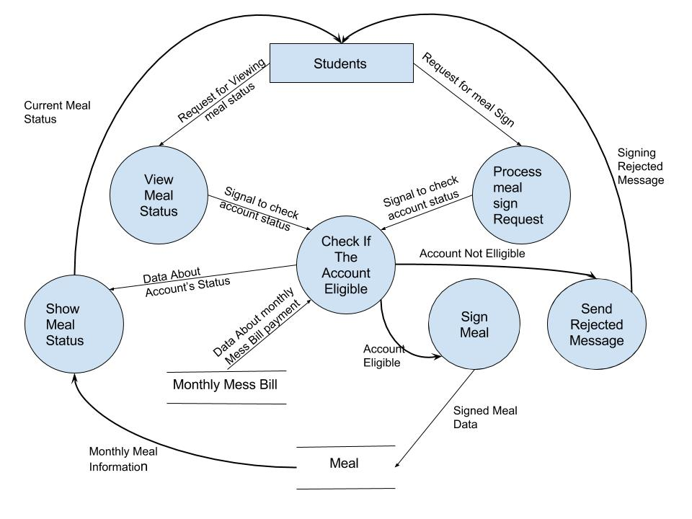 **Fig:** DFD For Signing meal

1. **Hall staff activities :**

Grocery information inputs the job of hall stuff. The Insert Daily Consumption process helps the help staff to input daily consumed food and food price had also updates the Monthly Consumption table. But before that, hall staff can know the number of students who signed meal the present day to assume the amount of food needed for that day through Show Number of Students with signed Meal process. The Calculate Daily expense Per Student process calculates daily mess expense per student taking input from Daily Consumption process and Meal Sign Table. Then Check Who Signed Meal process checks who signed meal that day and adds the per student mess expense to only their

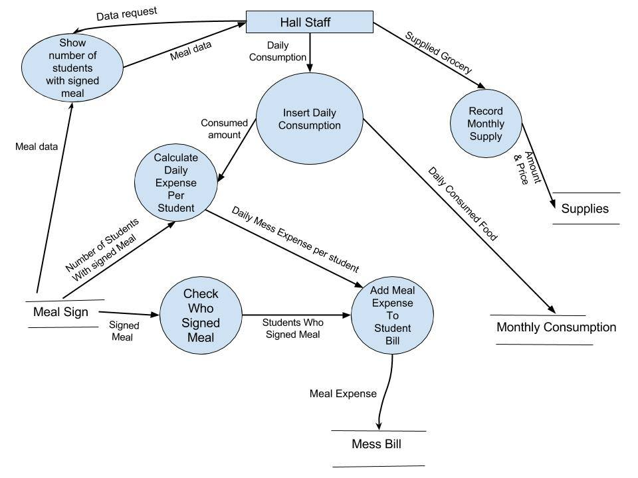

**Fig:** DFD For Hall staff activities

bills and then updates Mess Bill table. Though Record Supply process hall staff updates the Supplies table.

1. **The hall manager activity:**

Student request for creating account to the hall manager through create new student account process where it is checked by the validate information of the student. Which is saved in student database.The hall manager can also edit student account, update information and delete account if not validate.The create new account process and update student info process is related to the student database.

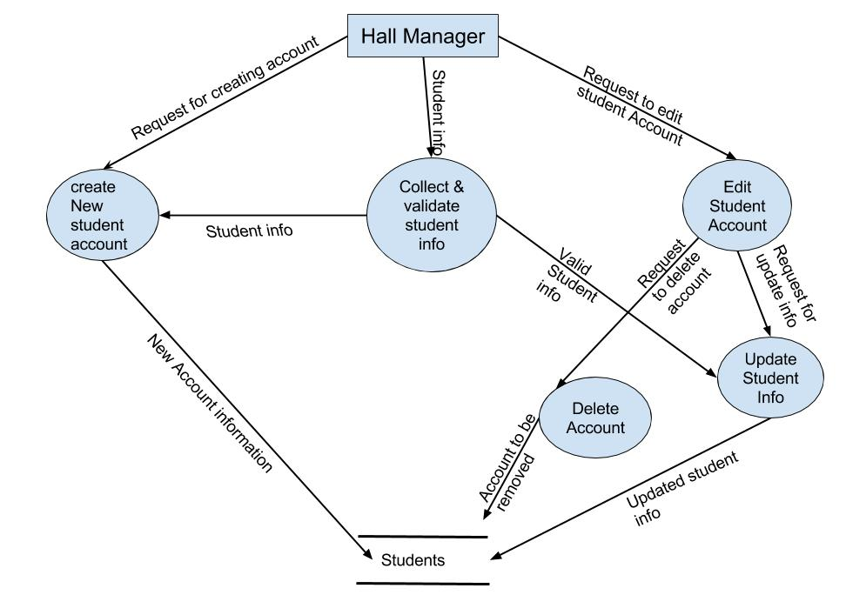 **Fig:** DFD For Hall manager activity

* **Class Diagrams:**

**1. Class diagram for signing meal:**

In the first class, there are 6 classes. Student class is has necessary methods and attributes where the responsibility is to show info. Hall admin does the same for hall manager. Both of them in inherited by member class to log in. member is inherited by login class. There can be many members of the hall admin and student, but each member has at most one log in. Student class is related to meal sign class where the relation in association and monthly consumption class is dependent on meal sign class for its methods.

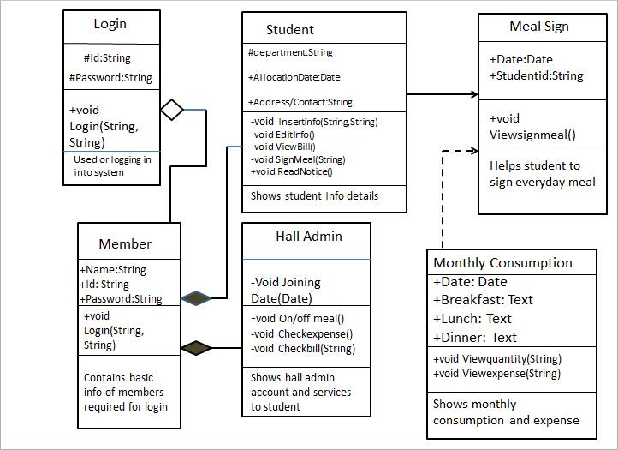

**Fig:** Class Diagram for signing meal

**2. Class diagram for viewing bill:**

Mess bill and hall bill class inherits student class which means it has necessary information of all students. Here the composition relationship works. Hall authority is linked to hall manager and hall staff which is a binary relationship. There responsibilities vary from each other in case of creating student id and inserting daily consumption methods though some of their attributes match.

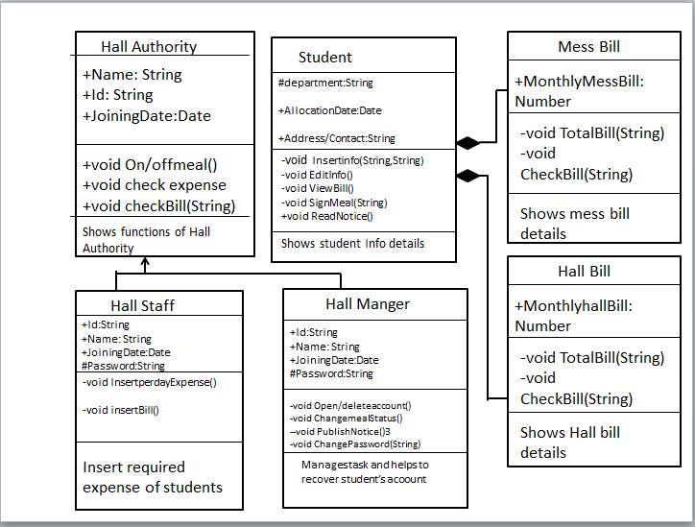

**Fig:** Class Diagram for viewing bill

* **Use case diagram:**

A **use case diagram** at its simplest is a representation of a user's interaction with the system that shows the relationship between the user and the different use cases in which the user is involved. A use case diagram can identify the different types of users of a system and the different use cases and will often be accompanied by other types of diagrams as well. Use case diagrams are a set of use cases, actors and their relationships. They represent the use case view of a system.

There are three types of use case diagrams used in our projects:

**1.UCD on student account control:**

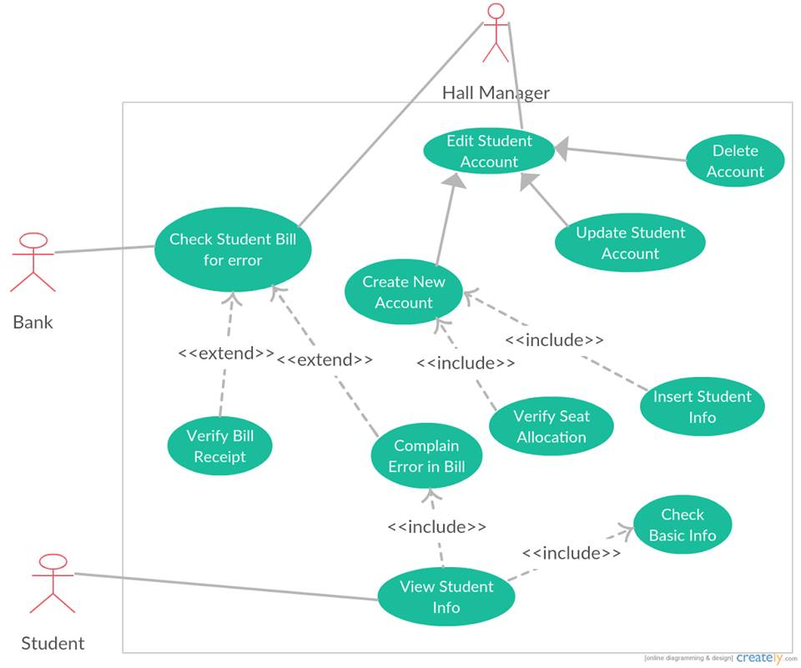

**Fig:** UCD on student account control

**Description:**

Here student acts as an actor for the use case diagram. He checks student bill through check student bill use case. This use case extends to verify and complain bill. Hall manager acts as an actor for edit student account which includes create account also. Verify seat and insert student info are include use cases of create student account. Complain error ‘includes’ view student info where student is an actor.

**2.UCD ON student meal sign:**

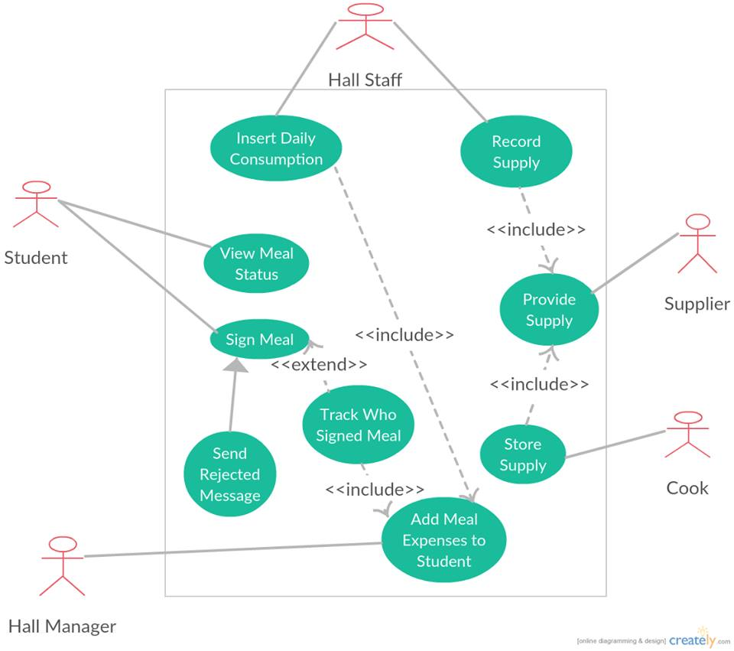

**Fig:** UCD on meal signing of student

**Description:**

4 actors are here. At first student acting for meal sign use case. This can be rejected by reject message process. Hall stuff acts for insert and record use cases. Insert includes add meal expense use case as well where hall manager is an actor. And record use case’s include use case is supply so here supplier is an actor. Cook also is an actor acts for store supply use case where it ‘include’ provide supply

use case.

**3.UCD On student view bill:**



**Fig:** UCD on student view bill

**Description:**

Student acts as an actor who is out of the boundary. He can pay bill and view bill. Those are use cases. Pay bill introduces two more use cases collect bill book and submit bill receipt so they are include version of pay bill. Bank works as another actor here for paying bill. And variation to this use case is submit fine. So this the extended version. Bill are of hall bill and mess bill these two types which initiates the use case insert bill in include section. Hall stuff acts as an actor for inserting bill and creating bill receipt to update the database. Whereas Hall manager acts on collecting bill receipt use case.

* **Sequence diagrams and corresponding use case scenarios:**
  1. **Sequence diagram for student’s account:**

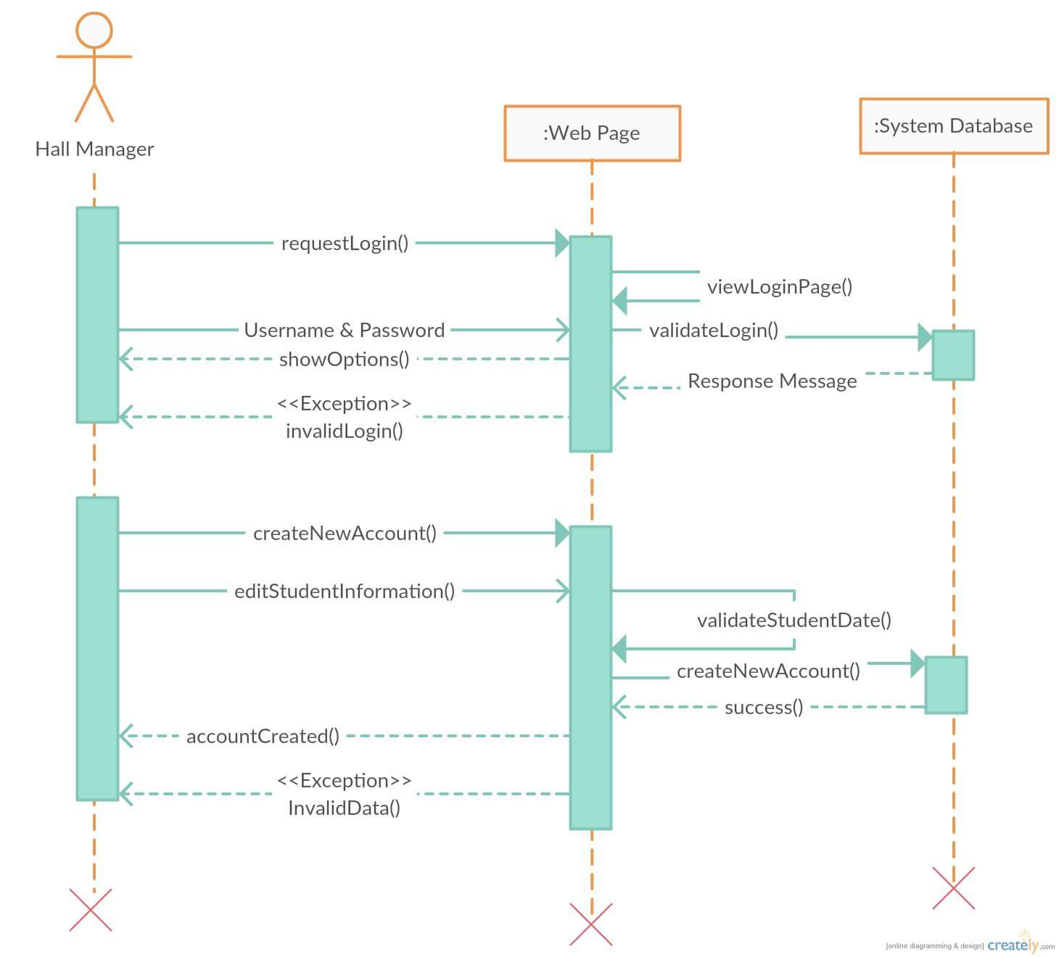

**Fig:** Sequence Diagram for student’s account

**1.Use case scenario for student account:**

**Use case title:** Osmany_Hall_Messing_System_student_account UC1

**Use case description:** This use case describes the flow of managing student accounts

**Primary actor:** Hall manager

**Stakeholders and interests:**

-Students: who will sign meal and view bills.

-hall manager: who will open student accounts and update necessary informations .

**Preconditions:**

1.Student must be hall resident.

2. Student must open an account:

**Post conditions:**

User will be able to sign meal and view bills successfully.

**Main success scenario:**

1. Hall manager will open a student account

2. He will provide the account name and password to the student.

3. Students can access their account after that.

4. They can manage their profiles.

5. They can add their photos.

6. They can also modify their necessary informations.

**Alternative flows:** N/A

**Special Requirements :**

* Software must be user friendly and secured.
* Compatible devices must be pre determined.
* Database management must ensured.
* Invalid login must be prevented.

**Technology and Data variations list :**

* Validity of data entered by user must be checked.
* Proper data format must be mentioned.
* Data compatibility must be must be maintained.

**Frequency of operations :** Could be nearly continuous.

* 1. **Sequence diagram for signing meal:**

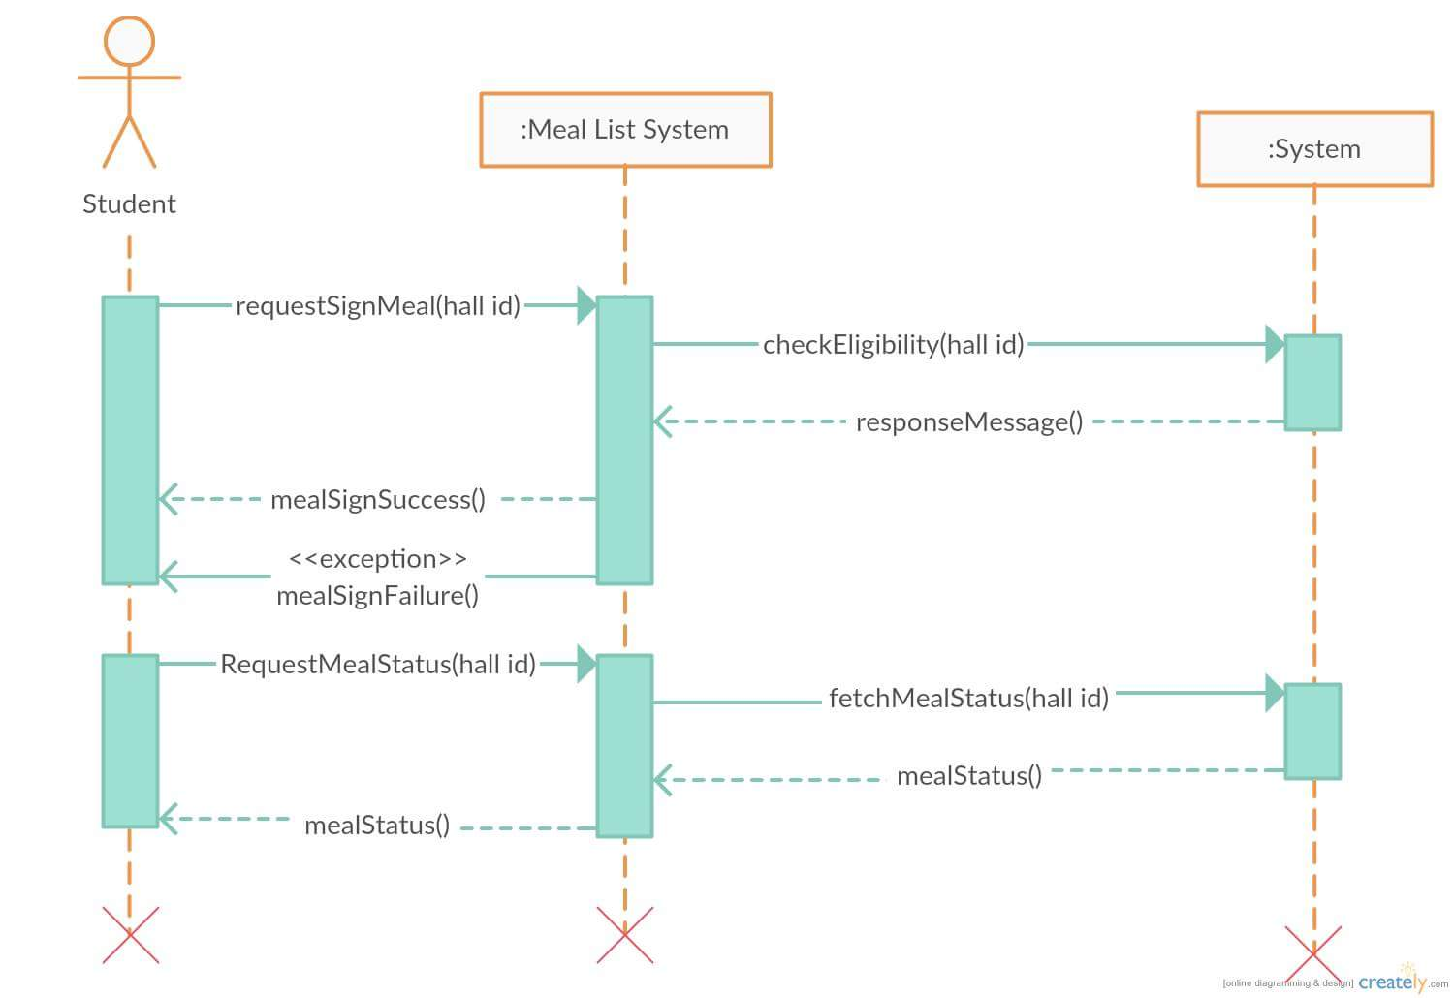

**Fig:** Sequence diagram for signing meal

**2.Use Case Scenario for signing meal:**

**Use case UC1:**Osmanyhall_messing_system UC2

**Use case description:** This use case describes the flow of signing meal of a hall student

**Primary Actor:** Student

**Stakeholders and Interests:**

* **Student:** Wants to order meals of next day perfectly without any error .
* **Hall Cook:** Wants to get total number of orders group by meal-time.
* **Hall Management :** want to get proper track of meal, it’s count and student and grand totals for each individuals.
* **Hall Manager :** Wants to get monthly bill without errors perfectly and categorized.

**Pre Condition :** Student is identified and unique.

**Post Condition :** Order is saved and total number of order is calculated as per meal time and also as per student.

**Main Success Scenario :**

1. Student log in to his account and order for meal.
2. Meal ordered as per student and also as per meal time .
3. Meal ordered for next day and cook get total count of meals as per meal-time.
4. Hall management gets total number of meal for individual students and for given time duration.
5. Each student gets his/her monthly bill from the system with proper report of meals
6. Students pays bill and updates it to their account.
7. System shows each students payment reports and also meal reports perfectly.

**Extensions :**

1. If system fails :
   1. Hall management ensures restarting system.
   2. Students to check their account and meal states.
2. Orders should be made before starting calculation for next day.
3. Time limit for ordering must be maintained.
4. User validation must be ensured.
5. Cancelation of orders must be in time limit.
6. Payments must be updated in time properly.

**Special Requirements :**

* Software must be user friendly and secured.
* Compatible devices must be pre determined.
* Database management must ensured.
* Invalid login must be prevented.

**Technology and Data variations list :**

* Validity of data entered by user must be checked.
* Proper data format must be mentioned.
* Data compatibility must be must be maintained.

**Frequency of operations :** Could be nearly continuous.

* 1. **Sequence diagram for view bill:**

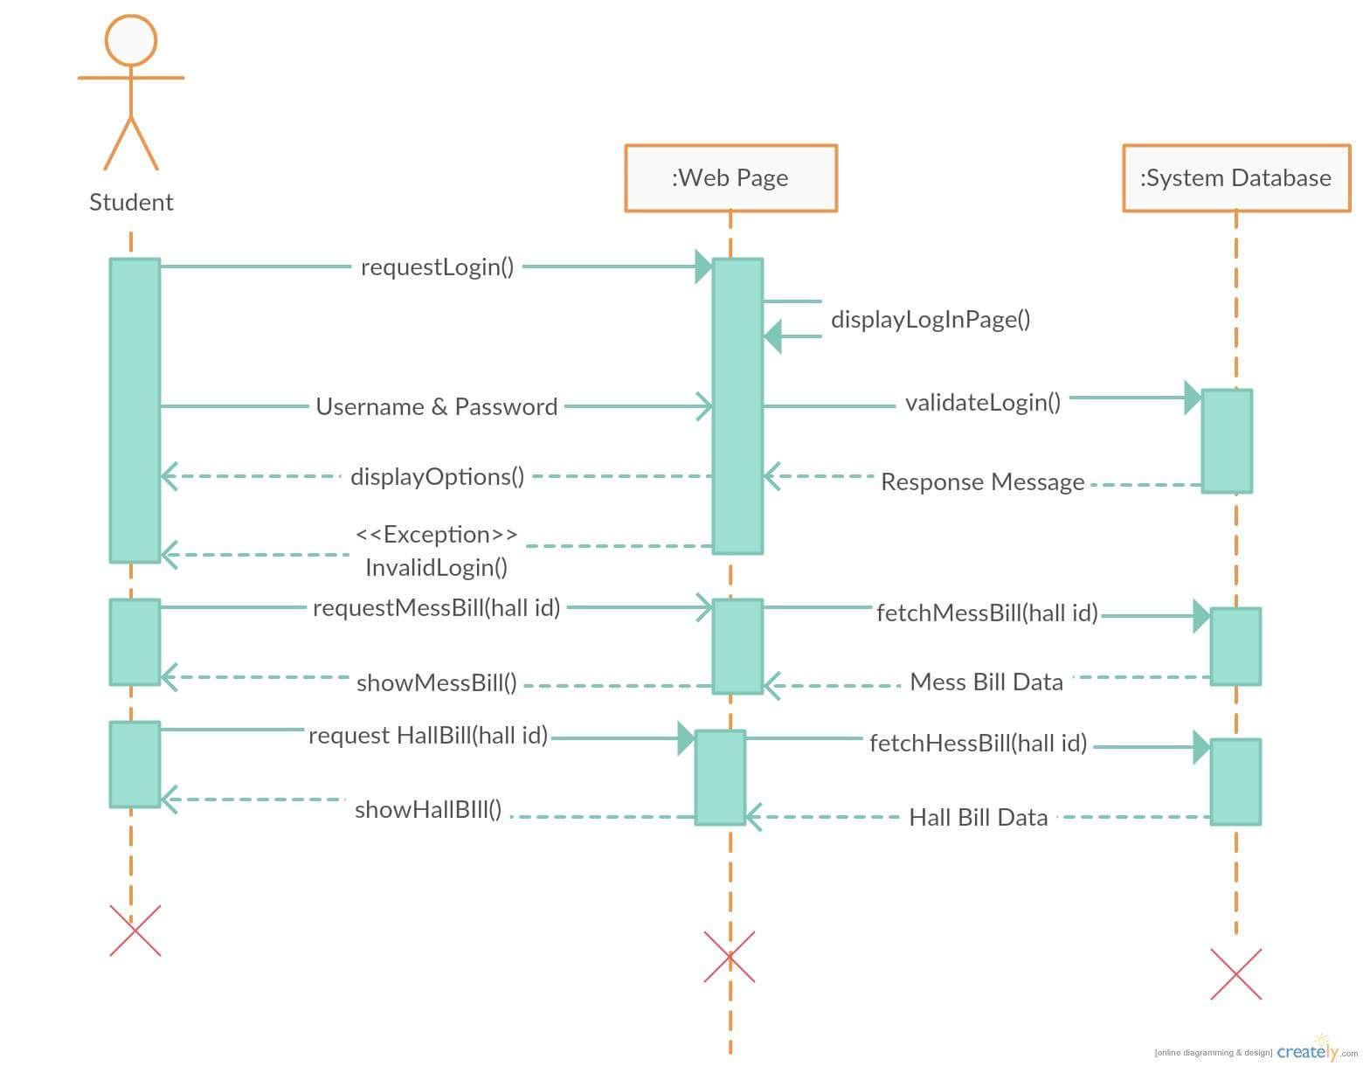

**Fig:** Sequence diagram for view bill

**3.Use Case Scenario for view bill:**

**Use case title:** Osmanyhall_messing_system_view_bill uc3

**Use case description:** This use case describes the flow for viewing the bill of a hall student

**Primary Actor:** Student

**Stakeholders and interests:**

* Student-who can view their mess and meal bill.

**Pre conditions:**

1. Student must be an authorized user.

2. Student must have view bill privilege in the system.

3. The bill information must be presented in the system.

**Post conditions:**

Student must be able to see his mess bill and hall bill.

**Main success scenario/Normal flow:**

1. Student: initiates to view meal information.

2. System: will give students two options, hall bill and mess bill.

3. Student: will choose one of the options.

4. Student: will display the bill based on selected options.

5. Students: bill information in database is updated by administrator.

6. Student: can see their individual bills for months.

**Alternative flow:** N/A

**Special Requirements :**

Software must be user friendly and secured.

Compatible devices must be pre determined.

Database management must ensured.

Invalid login must be prevented.

**Technology and Data variations list :**

Validity of data entered by user must be checked.

Proper data format must be mentioned.

Data compatibility must be must be maintained.

**Frequency of operations :** Could be nearly continuous

We are working to build software for controlling and overall management of Osmany Hall messing system which is presently done on manual measures. We tried to focus on the users and easy interaction procedure so that it everyone visiting and using the software gets a wonderful and complete experience

We look at some of the pages of our software below:

**Home Page:**

Our home page is a scrolling home page with some main options: authority, facilities, hall info, contact and login alongside. It contains additional information such as rules and regulations, facilities and also history about hall.

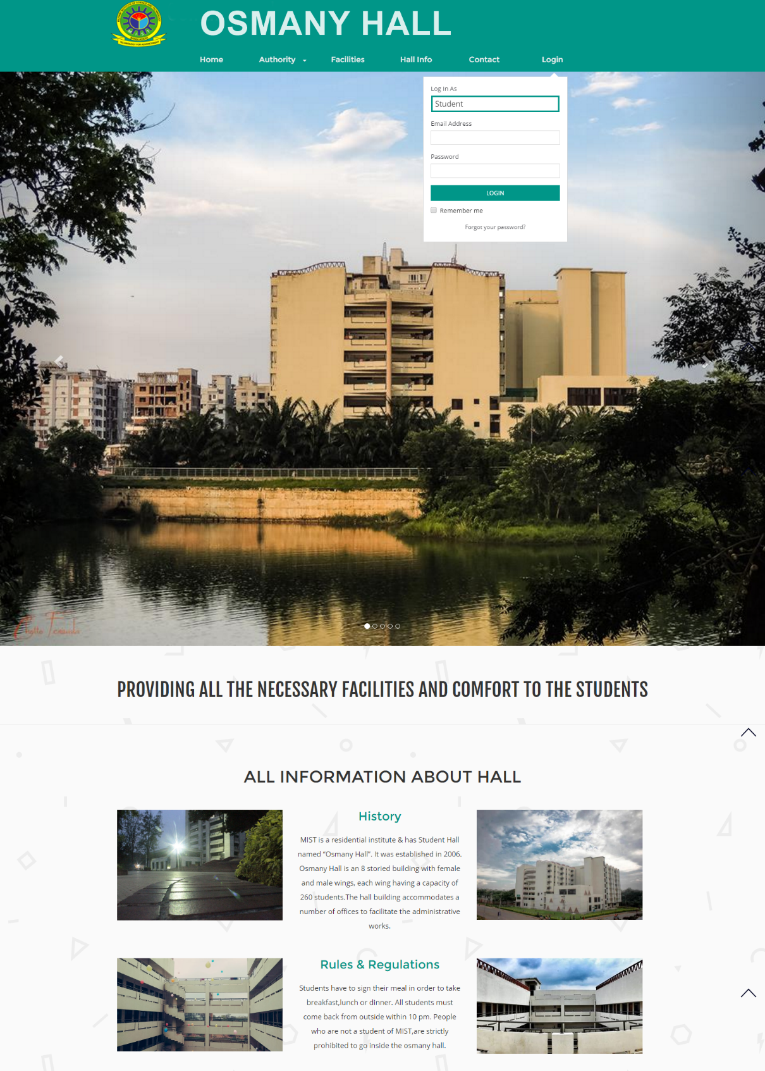

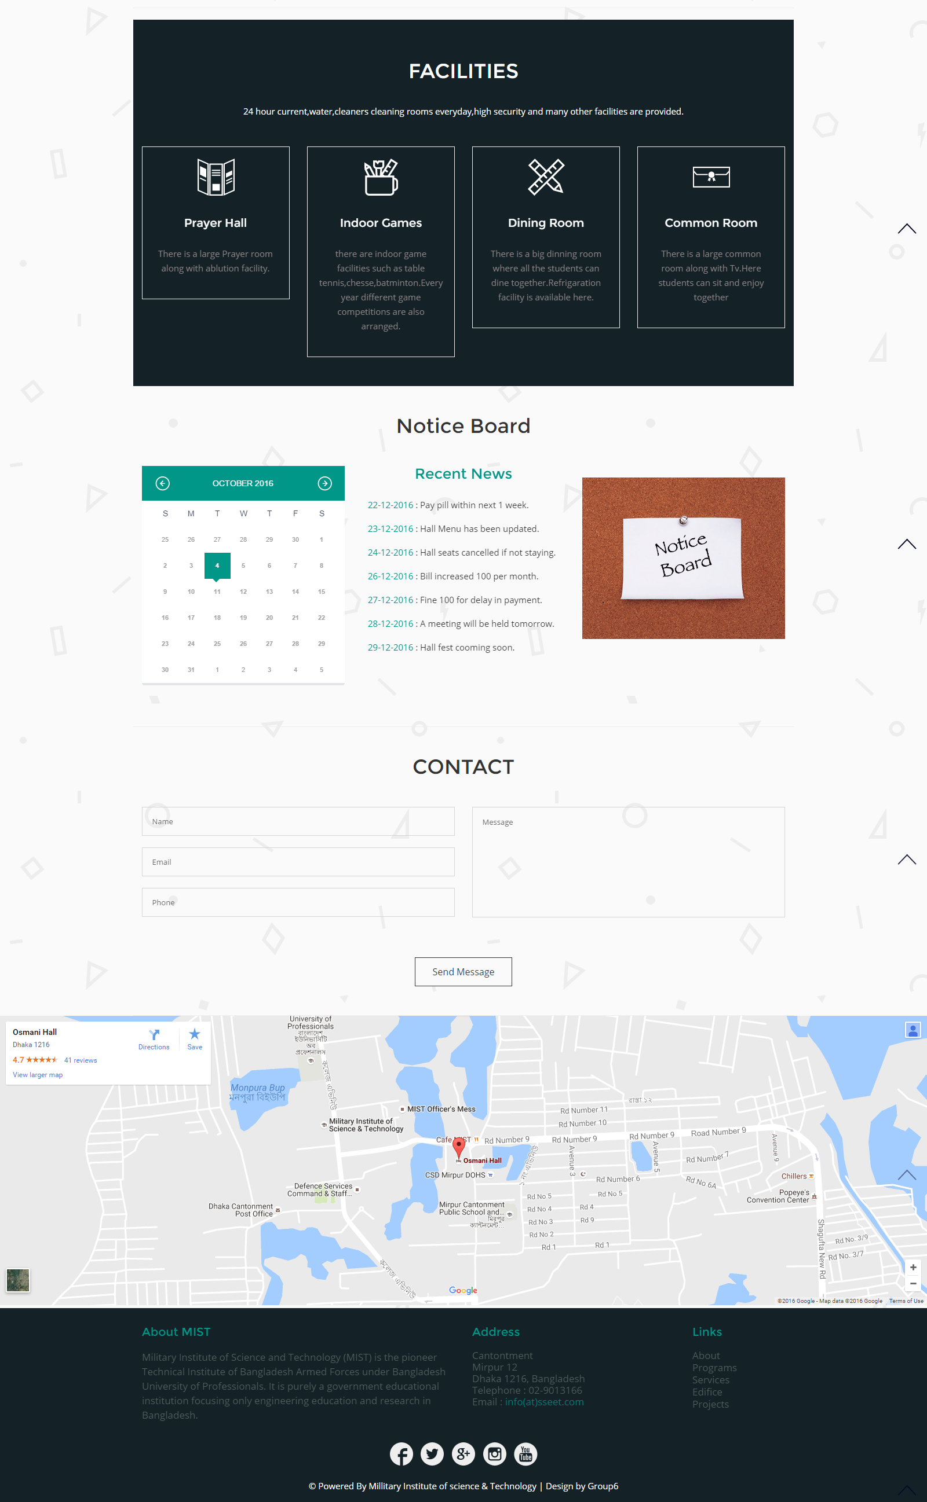

**Hall Authority:**

This page contains information about hall staffs and their contact information. On any emergency or need the students can contact to the authority through the given info.4

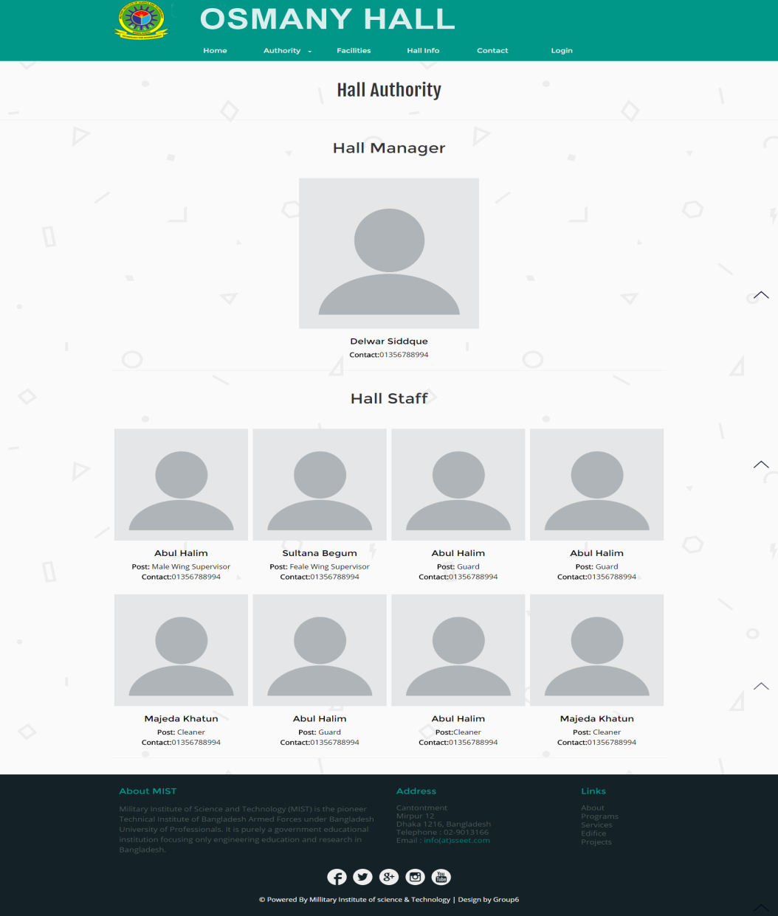

**About Us:**

The about us page contains information about the aim with which the software has been created and information about the developers.

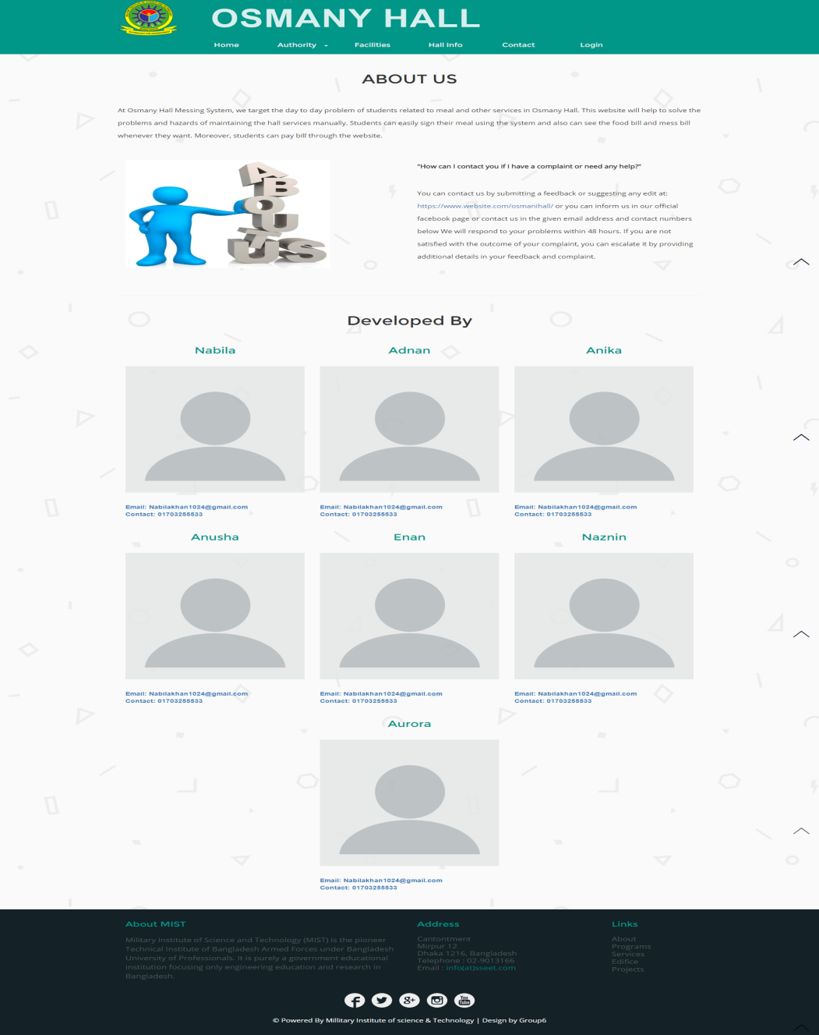

**Hall Bill:**

This is the page displaying hall bill of an individual student. Once a student logs into his own account this page on clicking the hall bill option will appear. This displays the month and the bill for that month, the paid amount, remaining or fines in a tabular form. On the left side the year bar is given from which particular year can be chosen.

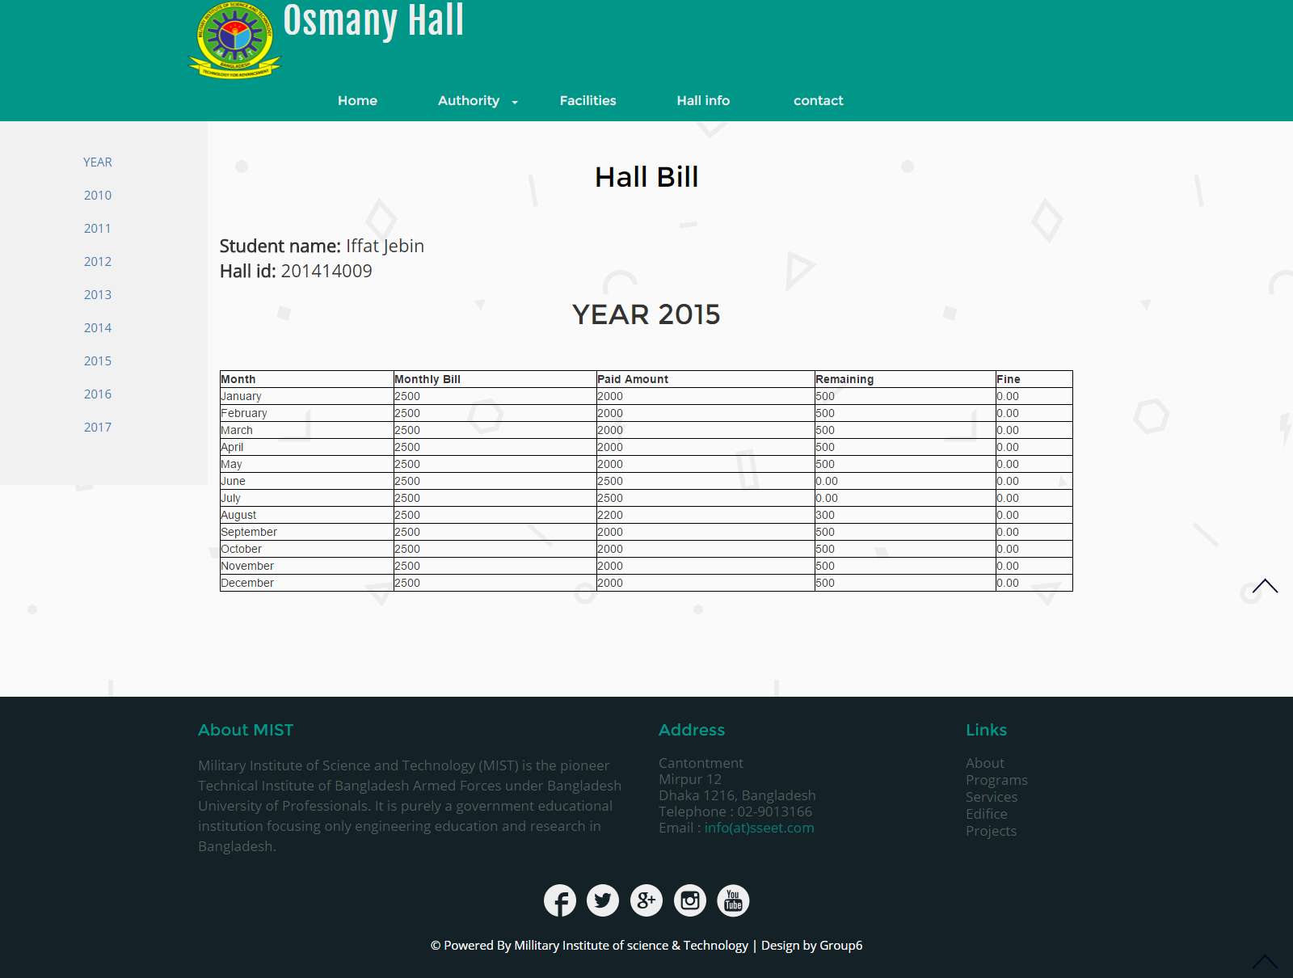

**Mess Bill:**

On clicking the mess bill option student will be showed a page as below. It will display the months, the monthly bill, paid amount and remaining amount with fine. This page also provides a year bar on left side that carries info for those years, from this page on clicking home user can go to the home page.

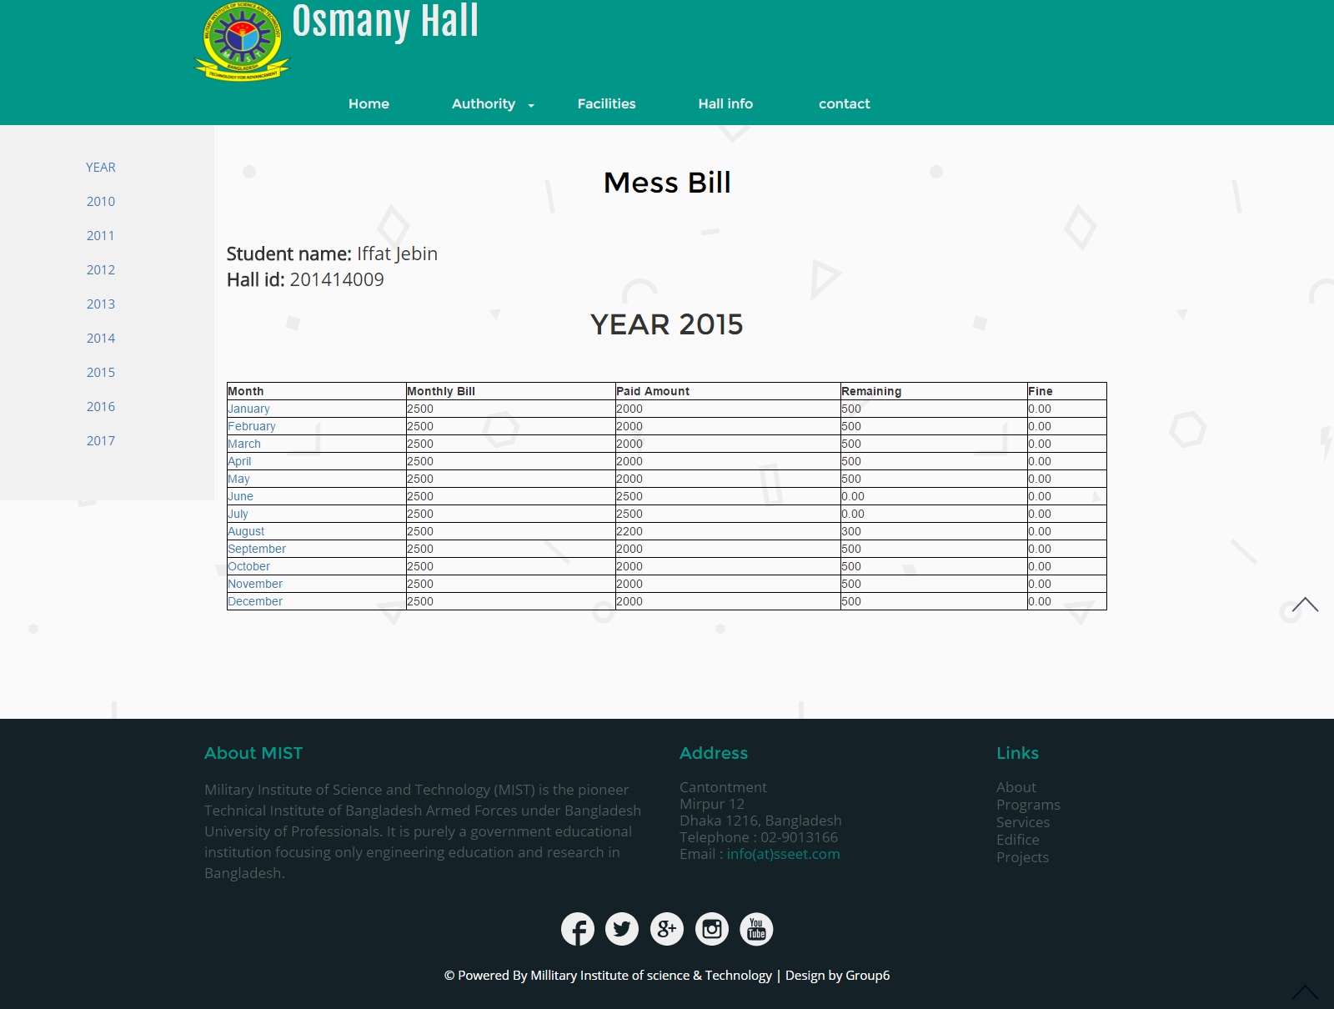

**Students profile:**

In the left side there is a navigation bar. Student profile contains basic info about student. Some of them can be updated by students and other by the hall manager. Student will be logged in as a student. He can sign mean for 3 different times a day and view bill also.

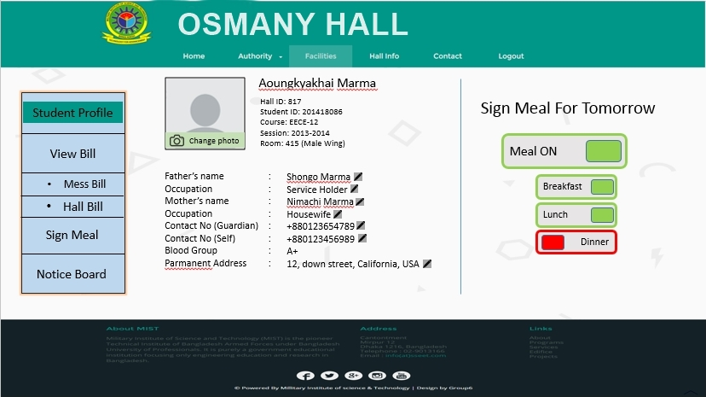

**View bill:**

For viewing bill there are two types of categories. Hall bill and mess bill.Mess bill is per the day. It shows the bill per time of the day individually and als shows the grand total of breakfast dinner and lunch. The mess bill is listed month wise.

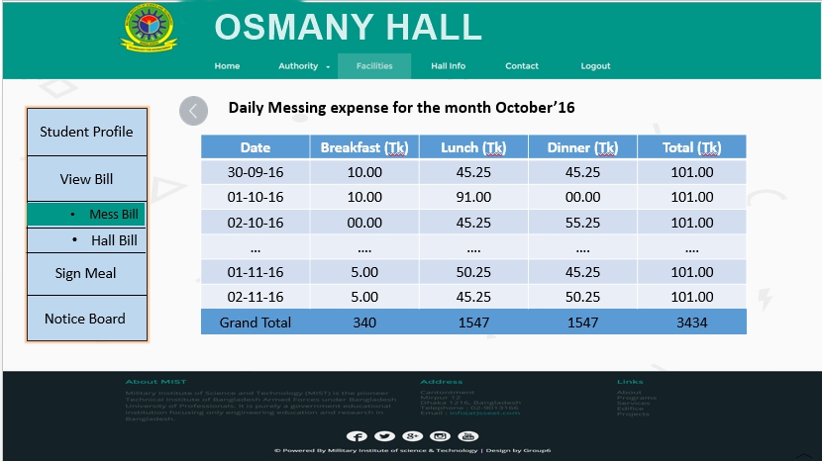

**Managers profile:**

Hall manager plays the vital role in our software system. Hall manager will open an account for students and will provide an id to them. This ID will help student to login into their account. He can manage, modify and update student information. He can update all the necessary information regarding the billing system as for example signing meal, total hall bills etc. he can provide notice and also create account of hall stuffs.

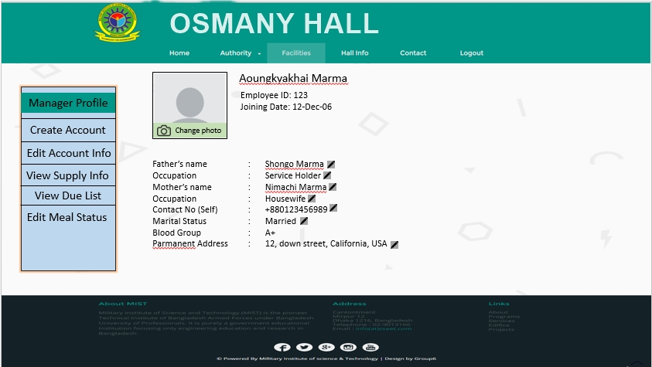

**Hall staffs profile:**

Hall stuffs are the assistants to hall manager. Basically they input the grocery item and maintain the meal system and other stuffs. There are nearly 50 staffs in both the wings. They have their individual accounts in the website opened by the hall manager through which they can update students’ info and input necessary information about student’s meal, and purchased grocery items. The page contains their basic information and edit options for groceries and meal.

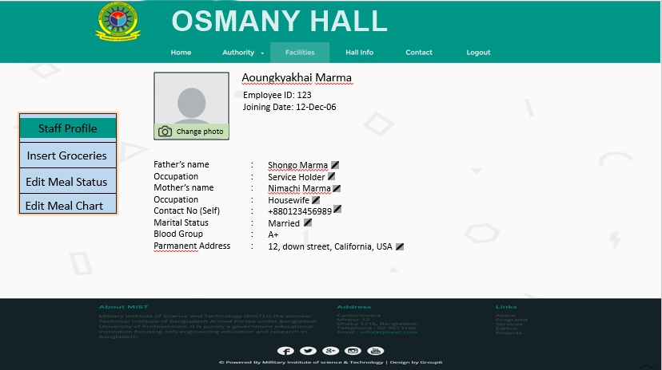

* **Conclusion:**

We have shown almost all implementations of these mockups. Our respected instructors have guided us in this case. We have also many features which we hope to implement further.